FATIMA JINNAH WOMEN UNIVERSITY

GROUP MEMBERS:
- SANIA ARSHAD (2023-BCS-098)
- EMAN WAHEED (2023-BCS-027)
- AMNA ABID (2023-BCS-007)
- ZARHA BASHIR(2023-BCS-092)
- ARSHIYA SAHKEEL(2023-BCS-017)
- MOOMNA ATIQ(2023-BCS-065)
SEMESTER: 2-A
DEPARTMENT: COMPUTER SCIENCE (BCS)
SUBJECT: OBJECT-ORIENTED PROGRAMMING LANGUAGE (LAB)
SUBMITTED TO: SIR. ADEEL KHALID

PROJECT REPORT:
TOPIC NAME:
SOCIAL MEDIA PLATFORM MANAGEMENT SYSTEM:
Here's a detailed project report for a social media platform management system developed using Java. This report includes the project overview, objectives, design, implementation details, and a conclusion.
- Introduction:
Project Overview:
The Social Media Platform Management System is a comprehensive software application designed to enable users to interact, share content, and build communities online. The system supports functionalities such as user registration, content posting, commenting, liking, sharing, following, and messaging.
Objectives:
- To design and implement a scalable and secure social media platform.
- To enable users to create and share content.
- To facilitate interactions through comments, likes, shares, and messages.
- To provide robust user management and content moderation features.
- To ensure data integrity and performance optimization.
- System Design:
Class Diagram:
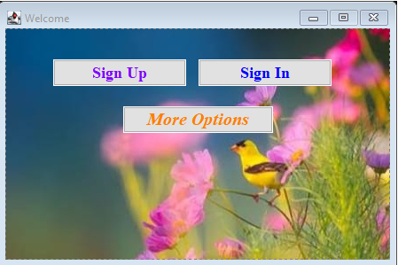
Key Classes:
- USERS
- FRIENDS
- POSTS
- LIKES
- MESSAGES
- PROFILE
- COMMENTS
Attributes:
USERS: User consist of userid(PK), name and password.
FRIENDS: Friend consist of status, userid(FK) and friendid(PK).
POSTS: Post consist of userid(FK), content and id(PK).
LIKES: Likes consist of id(PK), userid(FK) and photoid(FK).
MESSAGES: Message consist of id(PK),date sent and receiver id(FK).
PROFILE: Profile consist of id(PK),userid(FK) and bio.
COMMENTS: Comments consist of id(PK), postid(PK),date posted id and content.
- Implementation:
User Registration and Authentication:
- Registration:
Users can register by providing their username, email, and password.
- Authentication:
Users can log in using their email and password. Passwords are stored as hashed values for security.
Content Management:
  - Posting: Users can create posts with text and optional media.
  - Commenting: Users can comment on posts.
  - Liking and Sharing: Users can like and share posts.
Messaging:
  - Sending Messages: Users can send direct messages to each other.
  - Reading Messages: Users can read received messages.
DATABASE SCHEMA:
The database schema for your social media application includes tables for Users, Friends, Comments, Posts, Likes, and Profiles. Each table is designed to store relevant data and ensure the integrity and relationships between different entities in your application.
- Conclusion:
The Social Media Platform Management System successfully provides a robust and scalable platform for users to interact and share content. Through careful design and implementation, the system ensures data integrity, security, and performance. Future enhancements may include additional features such as real-time notifications, advanced search capabilities, and enhanced privacy controls.
This report outlines the essential components and their implementation in the project. It provides a comprehensive overview suitable for academic or professional purposes.

